4.1 Fundamentals of SQLite
4.1.1 What is SQLite?
SQLite is like carrying a mini-database in your backpack. No internet or server needed — just unzip it and use!
- SQLite is a lightweight, open-source, embedded database system.
- Unlike MySQL, Oracle, or PostgreSQL, it does not require a separate server.
- Data is stored in a single file (e.g., mydb.sqlite or mydb.db).
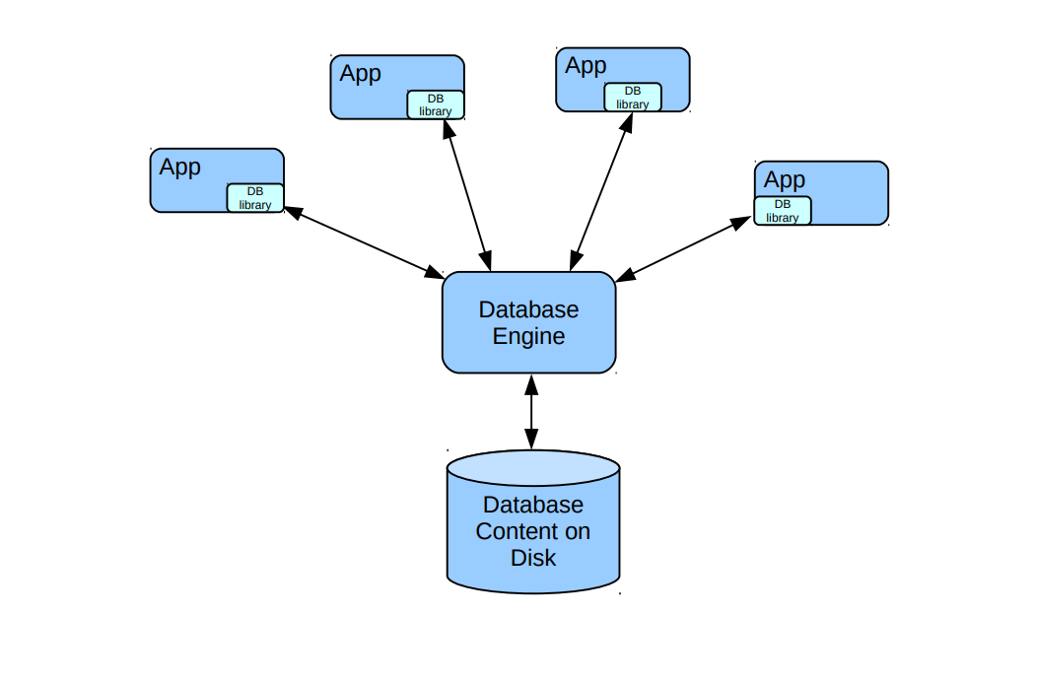
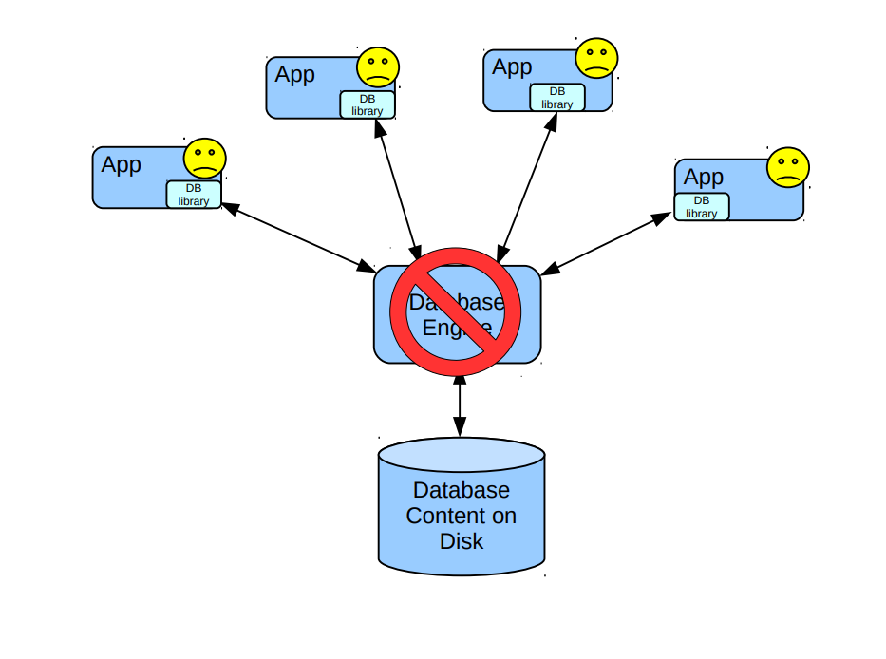
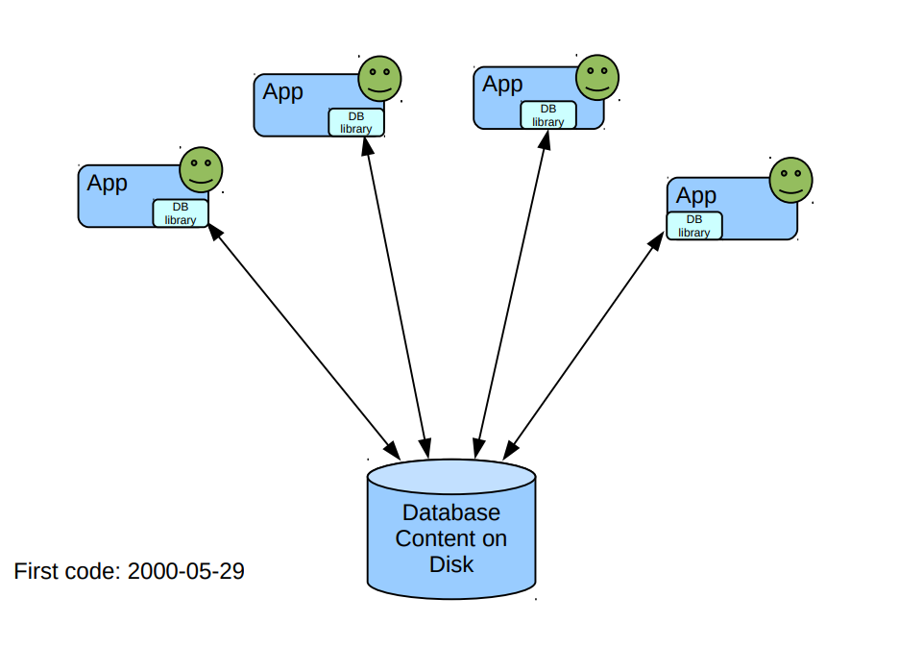

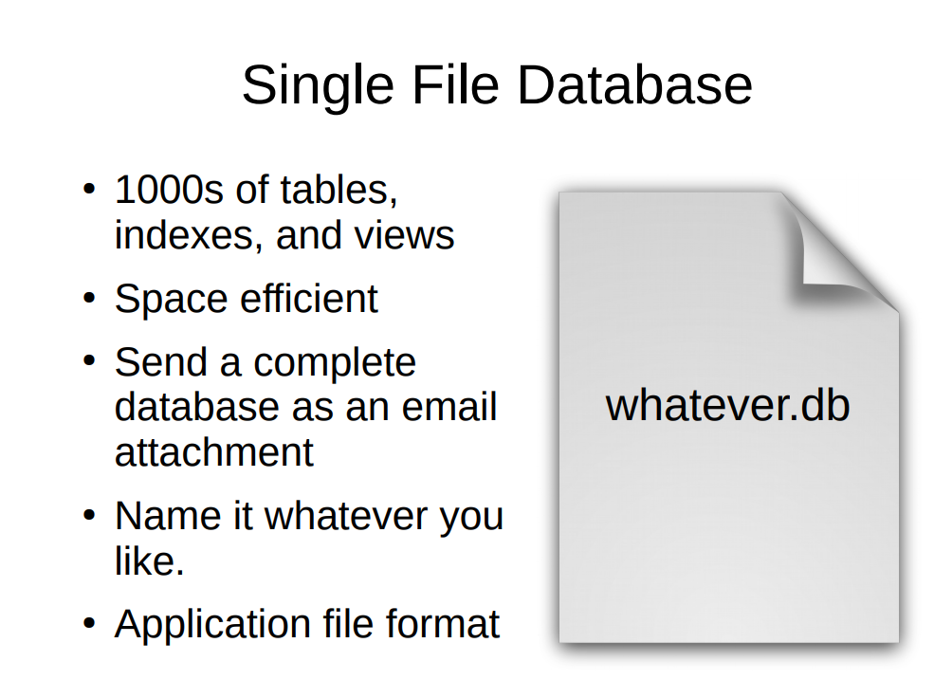

Key Features of SQLite
Serverless | no separate process, database runs directly in applications.
Zero-configuration | no installation or setup needed
Cross-platform | works on Windows, Linux, macOS, Android, iOS.
Single file storage | all data in one .db or .sqlite file.
Lightweight & Fast | small size, suitable for mobile and embedded systems.
Open-source | free to use, included in Python by default
Transactional | supports ACID (Atomicity, Consistency, Isolation, Durability).

Use-Cases of SQLite
Mobile apps (Android, iOS) | store local user data.
Web browsers (Chrome, Firefox) | manage history & cache.
IoT devices | lightweight storage.
Desktop applications | small/medium datasets.
Prototyping | quick testing before deploying on full RDBMS.

4.1.2 SQLite Data Types
SQLite uses dynamic typing → a column can store any type of value (not strict).
However, it provides five primary data types:
- NULL
  - Means no value, empty, or unknown.
  - Imagine a student hasn’t given their email yet.
  - We keep the place empty using NULL.
Example :
INSERT INTO Students (id, name, age, email)
VALUES (1, 'Amit', 20, NULL);

- INTEGER
  - Stores whole numbers (1, 2, -5, 1000).
  - Example: Age, Roll Number, IDs.
Example :
INSERT INTO Students (id, name, age)
VALUES (2, 'Herry', 21);

- REAL
  - Stores floating-point numbers (3.14, 25.6).
  - Example: Salary, Price.
Example :
INSERT INTO Products (id, name, price)
VALUES (101, 'Laptop', 45000.75);

- TEXT
  - Stores string values (names, addresses, messages).
  - Example: "Python", "Hello".
Example :
INSERT INTO Students (id, name, age)
VALUES (3, 'Suresh', 22);

- BLOB (Binary Large Object)
  - Stores binary data (images, audio, files).
  - Example: Storing profile pictures in database.
Example :
INSERT INTO Files (id, file_data)
VALUES (1, X'FFD8FFE000104A464946');

Example Table: students
CREATE TABLE students (
id INTEGER PRIMARY KEY,
name TEXT NOT NULL,
age INTEGER,
gpa REAL,
photo BLOB
);

Column | Data Type | Description
id | INTEGER | Unique ID for each student
name | TEXT | Student's full name
age | INTEGER | Their age
gpa | REAL | Grade Point Average
photo | BLOB | Picture stored in binary form

📘 Data Type Examples in Practice

INSERT INTO students (id, name, age, gpa)
VALUES (1, 'Alice', 20, 3.8);

- 1 → INTEGER
- 'Alice' → TEXT
- 20 → INTEGER
- 3.8 → REAL

importing sqlite3 module

